**Intern Weekly Activities Log Sheet**

|  |  |
| --- | --- |
| **Name:** | **John Clarence O. Joven** |
| **Course, Year & Section:** | **BSIT 4I-G2** |
| **HTE:** | **Accenture Phillippines** |

**Instructions:**

- Interns are required to fill out this log sheet daily to track their activities and progress.

- Provide a brief description of each task or activity performed during the day.

- Note the start and end times for each task.

|  |  |  |  |
| --- | --- | --- | --- |
| **Date/Time** | **Task/ Activity Description** | **Comments/ Details** | **Screenshot** |
| *9:00 AM- 12:00Pm* | *Conduct daily lesson viewing.* | *I did the daily task of viewing the learning materials making sure to understand and learn the things being taught in the lessons.* |  |
| *1:00- 5:00Pm* | *Continue the lesson viewing and apply the lessons learned in personal project of creating my own portfolio.* | *Applied the lessons and continued watching for further guidance.* |  |
|  |  |  |  |

Overall Progress Today:

[/] Achieved daily goals.

[x] Encountered challenges (please specify):

- ________________________________________

- ________________________________________

Additional Notes/Comments:

- __________________________________________

- __________________________________________

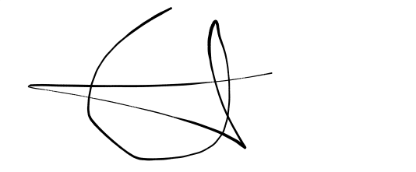

Intern Signature:________________________

Date: February 20, 2024